

Concordia Institute for Information System Engineering (CIISE)

## Concordia University

**INSE 6630 – Recent Developments in Information Systems Security**

## Project Report:

**Who could be the next Ethereum?**

Submitted to:

**Professor Jeremy Clark**

Submitted By:

**Nithish Reddy Yalaka – 40164619**

**Sukesh Gandham – 40185000**

## **Abstract**

## Ethereum was launched in 2015 and is one of the top crypto cryptocurrencies (ETH) and is a public, decentralized blockchain network which acts as open-source and is used around the world, in terms of technology, decentralization and market capitalization. Ethereum became the first blockchain network that introduced smart-contract functionality to the world of crypto and supported more than digital crypto assets. Ethereum enables peer-to-peer transactions with its own in-house cryptocurrency, ether, and it allows the creation and development of Decentralized Finance tokens , smart contracts, Fungible and Non-Fungible Tokens (NFTs), decentralized applications (DApps). Ethereum is the fundamental basis of the blockchain functionality that has supported many more of modern enterprises in their growth, and its technology creates a powerful infrastructure for the crypto ecosystem by allowing decentralized applications to run automatically on a blockchain without the intervention of a third party. Ethereum (ETH), second only to Bitcoin (BTC), is one of the most prominent and trustworthy cryptocurrencies, distinguished as a blockchain platform that supports smart contract capabilities.

## Ethereum is an excellent cryptocurrency to invest in if you want to get into decentralized finance, nonfungible tokens. Ethereum popularity is projected to rise as the crypto environment expands and more customers enter the market to acquire crypto assets, makes it an ideal long-term investment. At the time of writing, Ethereum has a market valuation of more than $370 billion in the $2 trillion-plus crypto industry, and it is ranked No. 2 on CoinDesk after the leader, Bitcoin. The Ethereum network is very active, with more than 1 million transactions each day. Ethereum has constantly evolved, making timely updates, adding necessary support when necessary and revolutionizing the crypto world. However, the high gas fee has been a pain for all the investors, especially the smaller ones. To do a single swap on Uniswap, costs around 100 USD. Minting an NFT costs close to 300 USD in fees. This is one of the reasons, investors are looking for other alternatives, in other words, **ETH Killers**, that they think may replace ETH one day.

## There’s no doubt that Ethereum revolutionized the blockchain industry, however, the drawbacks of Ethereum’s network are well documented. The fact that Ethereum is the world's second-largest cryptocurrency has consequences, as increased usage leads to transaction bottlenecks, expensive transaction fees, ineffective power consumption, and delayed processing. These limitations in Ethereum's scalability may deter newcomers from investing in cryptocurrency, causing them to look for Ethereum alternatives. Polygon, Polkadot, Tezos, and Cardano are among the numerous blockchain ventures that have emerged to challenge its position. The so-called "Ethereum Killers" are growing rapidly and grabbing a larger share of the NFT market, but Ethereum still accounts for around 80% of NFT transactions. Notably, these new blockchains appear to be accomplishing it all with faster, cleaner technology and lesser transaction fees ("gas fees"), prompting some to question how long Ethereum can maintain its first-mover edge. In this report, we are going to discuss how these famed blockchain investments of Polygon, Polkadot, Cardano, and Tezos can overthrow Ethereum [29].

## **Introduction (What is Crypto and Blockchain?)**

Since the introduction of Bitcoin in late 2008, there has been a tremendous increase in interest in blockchains and distributed ledger technology. Bitcoin and blockchain technologies have opened a slew of new business and innovation prospects. Beyond cryptocurrency, the democratization principle of blockchains has attracted a wide range of applications in a variety of fields, including finance, healthcare, and logistics. Blockchains enable immutability and transparency of blocks, allowing for extremely trustworthy, append-only, transparent public distributed ledgers and a potential method for constructing trustless systems. Third-party auditing is supported by public blockchain systems, and some of them provide a high level of anonymity. The goal of blockchain is to make it possible to record and distribute digital information without the capacity to change it. A blockchain, in this sense, serves as the framework for immutable ledgers, or transaction information which cannot be modified, erased, or destroyed and because of this, blockchains are also known as distributed ledger technology (DLT). The number of active blockchains is experiencing exponential growth every day. As of 2022, there are approximately 10,000 active cryptocurrencies created on the blockchain, alongside hundreds of additional non-crypto currency blockchains [30].

The blockchain idea was first introduced as a research study in 1991, and it was not widely adopted until 2009 when Bitcoin became the first widely used cryptocurrency. In the years afterwards, the use of blockchains has increased due to the introduction of multiple cryptocurrencies, NFTs, smart contracts, and decentralized finance (Defi) applications. The blockchain is a distributed database that is shared across nodes in a computer network. A blockchain is a database that stores data in a digital manner, and they are well-known for its crucial function in maintaining a secured and safe decentralized record of transactions in cryptocurrency systems such as Bitcoin. The blockchain's unique feature is that it maintains data record integrity and security while also building trust without the need for a trusted intermediary. Data is stored in blocks on blockchains, which are then cryptographically interlinked together and when a  new data is received, it is recorded into a new block, which is then linked onto the preceding block, producing a sequential data chain. A blockchain may store a wide range of information, but the most common use case thus far has been as a transaction ledger. In the bitcoin system, blockchain is used in a decentralized fashion, which means that no single person or company has control over the system; rather, all users have collective control. The data entered into a decentralized blockchain is immutable, which means it cannot be modified and all Bitcoin transactions are forever recorded and accessible to anyone [30].

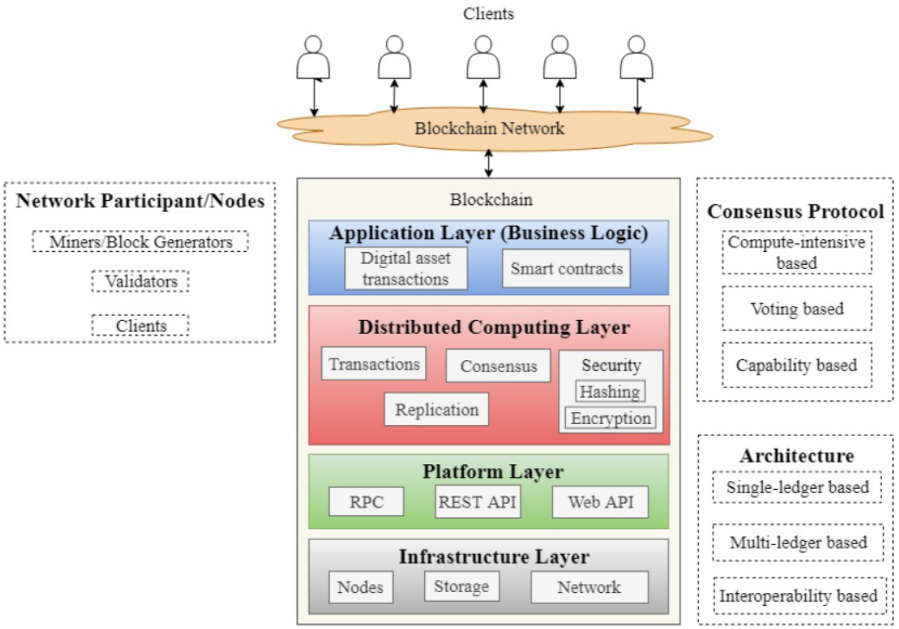

Fig1: Blockchain Architecture [31]

**Is the Blockchain secure enough**? Blockchain provides decentralized security and trust in numerous ways since new blocks are continuously saved chronologically and linearly, so the transactions have always been added to the end of the blockchain. Manipulating the information of a block after it was added to the end of the blockchain is extremely difficult except if a majority of the network agrees to do so because each block does have its own hash, and also the hash of the block before it and previously mentioned the time stamp. A mathematical function turns digital information into a string of letters and numbers, producing hashes, which will change when the information changes in any way. Due to the upscale of multiple cryptocurrency networks and also because of the rapid evolution, controlling 51 percent of a cryptocurrency network would be unfeasible and pointless. Members of the network would notice such major alterations to the blockchain, and such activities will not go unchecked. Network members then hard fork to a new, unaffected version of the chain and it would cause the targeted token's worth to fall, rendering the hack worthless as the adversary now has nothing but an unvalued asset. The same thing would happen if an adversary attacked Bitcoin's fresh fork as it was designed in such a way that participation as the network member pays off much better than attacking it financially [30].

**Consensus Algorithms**: Consensus algorithms, that are similar to BFT proofs, provide transaction integrity over a distributed network. Practical BFT (pBFT) can develop a consensus whenever a block is distributed with other members and the sharing information is communicated with others. Despite its immense popularity, blockchain systems are not without flaws and  t hanks to recent advancements in consensus algorithms, the time it takes to confirm a consensus and the amount of power it consumes on blockchain-based distributed ledgers have increased. Some of the most effective and widely used consensus mechanisms are Proof of Work (POW), Ripple Protocol Consensus Algorithm (RPCA) , Proof of Stake (POS), and Practical Byzantine Fault Tolerance (PBFT).

**How are Blockchains used in the real world**? The blocks on the Bitcoin blockchain store information about financial transactions and currently there are more than 10,000 plus additional cryptocurrencies that are currently operational on the blockchain. However, it has been discovered that blockchain may be used to hold information about various types of transactions and the technology has already been embraced by some of the high-profile companies like AstraZeneca, Pfizer, Walmart, AIG, IBM, Heineken, etc. Smart Contracts Healthcare, Fintech, Banking, Currency, Real-Estate, Trading, Supply Chain, Investing, and Voting systems are few of the very famous sectors where the blockchain is currently implemented and highly used in.

**Ethereum Killers (Who could dominate and replace Ethereum?)**

Blockchain technology is well-known for its decentralization and transparency. This is especially important in the financial sector. Several companies are exploring building new finance apps using blockchain systems. Through smart contracts, technology has made it simple to create new apps on blockchain networks. In blockchain-based finance applications, there is no need to be concerned about immutability, security, or decentralization. This is where a lot of companies are concentrating their efforts. Modern blockchain platforms have been created to help overcome these constraints and give practical value to different commercial applications and uses. We're seeing a lot of companies use blockchain platforms for some of their app needs.

The primary goal of blockchain applications is to improve the transparency and efficiency of business processes. Businesses are starting to see the value of blockchain technology and how it can help them grow. Businesses are experimenting with multiple platforms by developing blockchain apps, which is driving up demand for new blockchain platforms. Ethereum's shortcomings could hamper its scalability and capacity to establish a competitive crypto ecosystem in the long run. The vulnerabilities are expected to worsen as more people join Ethereum's network. Gas fees, or high transaction prices, are an issue for consumers who can't pay variable rates and enterprises who rely on a stable blockchain network. Ethereum alternatives provide a variety of answers to the Ethereum blockchain's network issues. Many of Ethereum's alternatives were created with the scalability issue in mind. High gas fees, power consumption, disc space use, network congestion, and GPU prices are just a few of Ethereum's critical issues. Let's have a closer look at some of the most popular Ethereum killers on the market right now.

**1. Polkadot (Dot)**

Dot is a new blockchain protocol that links the network of established blockchains, allowing them to function seamlessly together. Polkadot allows any form of data to be shared across any blockchain, opening the door to a variety of real-world applications. [11]

**Architecture**:

Polkadot connects a diverse blockchain network known as parachains. Such chains are linked together to make a safe relay chain. Polkadot also links to other networks using bridges. The Polkadot's core is a relay chain, which is in charge of consensus interoperability and network security.  Polkadot shard bridges allow the network to interface with other cryptocurrencies like Bitcoin and Ethereum. Parachains join the relay chain and subscribe for connectivity as they go. Another option is to lease a slot for continuous connections. As blockchain technologies can produce their own coins, relay chains aid in connecting to them. can have their own. [11]

Nominated Proof of Stake (NPoS) is a particular subcategory that is used. This NPoS picks validator sets by enabling nominators to decide the correct validators based on earlier success. The mechanism lets nominators vote on which validators are not acting maliciously. Polkadot network nodes are classified as validators, nominators, collators, and fishermen.

**Working Model:**

The DOT token is used for governance and staking. This token fulfils three unique functions: staking, system is properly, and bonding.

* **Governance,** Polkadot tokens have entire authority over the protocol. Relay Chain participants (DOT holders) will be allowed all the rights that miners have on other platforms, including the capacity to handle unusual occurrences such as protocol upgrades and corrections.
* **Bonding** tokens create new chain guards. By eliminating bound tokens, outdated or ineffective parachains are deleted. This is a type of proof of stake.
* **Staking** Token holders are incentivized to behave honestly via game theory. This system rewards good actors while penalizing bad actors by removing their access to the network to make sure the network is safe [11].

**Consensus Mechanism:**

It follows two-hybrid and complex consensus mechanism protocols. Two tools have enabled this to achieve block finality using GRANDPA (GHOST-based Recursive Ancestor Deriving Prefix Agreement) and this produces new blocks BABE (Blind Assignment for Blockchain Extension [12] This provides the network with the advantages of both probable and proven finality.

**GRANDPA:** This technique works if 2 different nodes behave normally and can operate concurrently with one-fifth of both the Byzantine nodes. When more than half of validators testify in favour of a chain including a specific block, all linked blocks before that block are finalized at the same time. GRANDPA relies on a chain rather than blocks, which considerably speeds up the transaction-completion process. Finalization occurs relatively immediately under perfect network circumstances. GRANDPA may theoretically finish millions of blocks concurrently during terrible network circumstances provided the concerns are fixed [12].

**BABE**: This technique generates new Polkadot network blocks. Verification nodes are responsible for determining the construction of new blocks. BABE assigns blocks generation slots to validators depending on the amount of DOT staked using a randomization cycle like the Ouroboros Praos consensus technique. Validators compete in a lottery for each slot to determine if they are the chosen block producer (several validators can compete for the same position) or whether the slot is unoccupied, resulting in different cluster timing [12].

**Key Benefits**:

* **Flexibility**: While constructing the chain for developers, maximum flexibility is allowed. To be a Parachain, it must demonstrate to Polkadot validators that each block of the Parachain meets the agreed-upon protocol [13].
* **Interoperability**: The ability of blockchains of different designs to communicate with one another is a critical component of the Parachain paradigm. Polkadot's interoperability, also known as cross-chain composability, implies that blockchains are no more independent entities cut off from one another [13].
* **Specialization**: Parachain was developed with the notion that the future of Web3 will entail several types of cooperating blockchains. This is since no single blockchain design is appropriate for every use case. To make it more suitable for the trade-off more suitable for applications and even less so for many others. Parachains may be adapted for almost any blockchain use case, and they can also be used to experiment with whole new use cases, particularly on Kusama [13].
* **Scalability**: Polkadot achieves scalability at layer-1 using the parachain concept, which is more decentralized and efficient than relying solely on layer 2. Polkadot distributes and processes transactions in parallel over an ecosystem of specialized layer-1 blockchains, considerably boosting performance and scalability over non-sharded networks [13].

**2. Tezos**

Tezos is a decentralized open-source blockchain that can perform peer-to-peer transactions and operate as a platform for smart contract deployment. The Tez, denoted by the sign XTZ, is the native coin for the Tezos network. Tezos follows a unique proof-of-stake mechanism that made it survive in the cryptocurrency market. Tezos differs from other aspects of its one-of-a-kind governance. Previously, blockchains relied on mining communities and development teams to establish or develop new design options. Tezos intends to integrate the decision-making system inside the network system itself [14].

**Architecture:**

Tezos architecture is defined by the relationships between its pieces. Tezos design employs Network Shell, an agnostic interface. This shell, which is separated into three nodes, allows developers to create a modular approach with a self-amending blockchain. The protocol stack oversees base station peer monitoring and publishing. The blockchain's accounting model is defined by the transactions protocol. The consensus algorithm outlines the method which helps the network in reaching agreements on operations and the current state. Both consensus and transaction protocols are incorporated in the tezos architecture [14].

**Working Model:**

The inventors of Tezos describe it as "stable, updatable, and resilient," underlining that the language of their smart contracts is as precise as high-value use cases need. The source code is developed by Combining multiple, fast, flexible, and expressive computer languages, but unlike the bulk of many other smart contract-enabled blockchains.

Bakers that generate contributions on the tezos network are compensated for identifying and distributing blocks. Baking on Tezos is analogous to blockchain staking. This technique works in such a way that if a block is successfully added to the network, 32 endorsers validate the block. If the verification is successful, the maker is paid, as are those who confirm blocks. However, if a block is incorrect, the baker must pay the fine; if many blocks are created, the baker would lose his standing and will no longer be able to make blocks.

**Consensus Mechanism:**

Tenderbake is just a proof-of-stake consensus method, that implies that members in the consensus procedure are chosen based on their commitment. This is the standard blockchain protocol. Tendermint has been updated for the Tezos blockchain. Tendermint is designed to interact with the Tezos design by leveraging communicative primitives and networking constraints. Validators in each block carry out as committee in Tenderbrake, who are participants picked at random based on their stake, like how endorsers are chosen in Emmy. The number of validator slots at each level is governed by the CONSENSUS COMMITTEE SIZE. Tender bake works in rounds at each stage. Every phase is an attempt by the validators to establish an agreement on the content of the block at the current level, i.e., the sequence of non-consensus operations included in the block. This is referred to as the block's payload [15].

In this mechanism each round has its own duration, round lengths are adjusted to handle the round delays and it is long enough to exchange all messages. Each round time of determined by the parameter in the protocol like MINIMAL BLOCK DELAY and DELAY INCREMENT PER ROUND. Parameters specify as follows:[15]

*Round_duration(0) = minimal_block_delay*

*Round_duration(r+1) = round_duration(r) =delay_incremen*

*= minimal_block_delay + (r+1) *d*

Below are the steps in each round:

* For that round, a validator inserts a nominee block (representing a proposal) and consensus procedures (going to represent votes) into the network to which it is connected. disseminates those transactions and consensus methods to other network nodes, passing them on to the validators connected with those endpoints, who decide on which block to approve [15].

**Key benefits:**

* **Innovative** upgrade Tezos has these options. There are four phases to upgrading. In the proposal, each user votes on which changes they feel should be tried. The recommendations with the most votes advance to the next round. To do this, a parallel network is built to test potential enhancements and ensure that they are safe and stable enough to be ultimately incorporated into the Tezos blockchain. The ones who fulfil this requirement specification goes on to the next round. Voters vote from the initial round of selected suggestions in exploration, and if the proposal receives a certain number of votes, it advances to the testing stage. **Promotion**: All networking users/voters vote on the successfully tested improvements. These modifications are subsequently posted to the Tezos network [15].
* **Safety:** Tezos network claims to provide safety and code correctness compared to other blockchain networks. It aims to provide safety to high-value use cases [15].

**3. Polygon (MATIC)**

The polygon blockchain network is a framework for developing two kinds of Layer 2 blockchains that operate alongside and interact with the Ethereum network. Polygon-protected chains rely on a pool of professional validators, whilst Polygon stand-alone chains are responsible for their own security and pool of validators.

**Architecture:**

Polygon design features a flexible validation layer that is segregated from various execution environments such as fully blown EVM sidechains and, in the future, alternative layer 2 techniques such as zero-knowledge rollups. Polygon mechanism is enabled by deploying the set of staking management contracts to Ethereum as well as a set of incentivized validators running Heimdall and BOR nodes. Although Ethereum is the first base chain that supports Polygon, polygon intends to offer support to other blockchains based on community suggestions and consensus to enable a decentralized layer 2 blockchain platform.

Polygon is a three-layered architecture:

* **Staking smart contracts** on Ethereum.
* **Heimdall (Proof of Stake validation layer):**  This layer is built on top of the Tendermint consensus engine and necessary consequence of the signature system or data signatures. The layer oversees transaction verification, blocks producer committee selection, checkpointing a side-chain block representation to Ethereum in our architecture, and a number of other functions [16].
* **Bor (Block producer layer):** This is a producer layer responsible for the aggregating transaction into blocks. Committee selection on Heimdall shuffles blocks periodically named as span in Polygon. Blocks are produced at the Bor node and the sidechain VM is EVM-compatible.

**Working Model:**

In Polygon Matic side-chain functions as other proof-of-stake-based blockchains. The structure, client nodes, token, and validator nodes are like other networks except for the factor the exchanges are clustered and settled over the Ethereum mainchain. Off-chain options are mentioned in Layer2 scaling solutions. This involves reducing or removing judgment power components from the main blockchain before they are executed elsewhere, such as on sidechains. This increases mainchain throughput and disperses skill evaluation throughout the network. Layer2 solutions are growing in popularity as they play an important role in the widespread acceptance of cryptocurrency [16].

This model requires the clients to interface with decentralized apps that have moved to the MATIC sidechain are required to verify the predicate contract conveyed to the Ethereum network letting the tokens be sent on the MATIC side chain. Once this predicate contract is verified MATIC stores the token in the side chain. A specific contract named RootchainManager activates another child contract named ChildChainManager this measures proper bolted or store tokens on the MATIC network. If the client accepts their tokens on the sidechain they can move within the network with minor expenses. RootChainManager will store back resources for the client’s location on the Ethereum mainchain when the cycle is finished.

**Consensus Mechanism:**

Polygon uses a Proof-of-stake consensus mechanism that enables a consensus to be achieved with every block. This method requires network participants to stake agree and not trade or sell their Matic in exchange to validate the Polygon network transactions. Polygon network aims to address the limitations of the Ethereum platform namely high transaction fees and slow transaction processing speeds. Polygon can deploy and develop custom blockchains and deploy new blockchain networks. This enables the communication between Ethereum and other blockchains. Also, help the existing blockchain network become compatible with Ethereum.

**Key Benefits:**

* **Quickly process transactions:** The polygon consensus mechanism completes the transaction confirmation in a single block this helps Polygon to maintain fast transaction speeds with an average processing time of 2.1 seconds [17].
* **Low Transaction fee:** Polygon charges a low transaction fee to use the platform around $0.01 [17].

**4. Cardano (ADA)**

Cardano, who hosts the ADA cryptocurrency, is a third-generation decentralized blockchain solid evidence platform. It is the first blockchain-based platform to originate from a scientific philosophy and study approach. It is a completely open-source initiative that aspires to build a global infrastructure that is inclusive, egalitarian, and robust for financial and social applications. Haskell, a functional programming language, is being used to write Cardano. Cardano will adopt a direct democracy approach, in the end, allowing the project to grow over time [18].

**Architecture:**

Cardano's layered blockchain concept is distinguished by two key components: the Cardano Settlement Layer (CSL) and the Cardano Computational Layer (CCL). Almost all other current blockchain platforms feature only a single layer to cause network congestion, impede transactions, and escalating expenses. The CSL powers Cardano's unit of account. Simply said, this is where peer-to-peer transactions, such as token transfers between users, take place. The Cardano network's heartbeat is the CCL. It assures the chain's security, acts as the starting point for smart contract implementation, and serves as a template designed to meet the network's goals while also ensuring regulatory compliance in various countries [19].

**Working Model:**

Cardano features a network of block producers that are responsible for adding new transaction data to the chain. Its security is guaranteed by the consensus method, which is regulated by validator nodes, who choose which blocks to use to continue the chain. Cardano's consensus system is regulated by the Ouroboros Praos protocol, which is a proof-of-stake (PoS) paradigm. It employs a block formation cycle based on epochs of 432,000 slots, every lasting around five days. Every epoch, block production nodes are tasked with choosing 21,600 slot leaders to oversee the whole process. Leaders are chosen randomly from stake pools based on their volume and seed. A multi-party computation (MPC) approach is employed to determine the seed [19].

**Consensus Mechanism:**

**Proof of stake** (ouroboros)

Ouroboros is a Pos protocol that has been demonstrated to be safe against adaptive attackers as well as scalable in a practical sense. Ouroboros protects against fully corruptive fully adaptive corruption in a semi-synchronous setting, to deceive any stakeholder at any time adversaries work not to affect the underlying blockchain to maintain stakeholder distribution honesty of stake and representatives of stake pool [20].

**Key Benefits**

### Eco-Friendly: Cardano is ecologically friendly and green. Because of its two-layer core architecture, Cardano's mining process is more efficient than that of other cryptocurrencies. The Cardano Clearing Level (CSL) is a clearing unit that allows users to trade ADA instantaneously and with low costs. The control plane is made up of protocols that perform numerous duties such as increasing identity identification, assuring security, and interacting with smart contracts, among others.

### Self-produced randomness: Ouroboros protocol has a global random oracle feature to generate randomness at each epoch [21].

Other benefits include Peer-reviewed technology, and Scalable.

**Out-of-Scope**

We have performed a detailed review and survey of different blockchain technologies architecture, consensus mechanism, benefits and working models. The topics below are out of the scope of this document.

**Non-Fungible Tokens:**

Non-fungible tokens are successive steps within the evolution of the core construct of cryptocurrencies. Modern money systems are created of complicated systems for commerce and funding of many sorts of assets, admire real estate, loan contracts, and works of art. NFTs are a leap forward in creating this infrastructure as they allow the digital illustration of physical assets [23].

**Hashing and Anonymization:**

Transaction data is kept on blockchain networks as data blocks, which are then linked together using hash values. Each block contains anonymized data pertaining to multiple transactions. As a result, each blockchain network participant may inspect the transactions but not their executors [24].

**Uni-Swap:**

Uniswap is a peer-to-peer exchange that allows for peer-to-peer market making. Uniswap is a cryptocurrency that goes by the symbol UNI. Users can exchange cryptocurrencies on the Uniswap platform without the intervention of a centralized third party [22].

**SOLANA, AVALANCHE, ALGORAND, STELLAR, ELROND.**

**Future Work (Ethereum 2.0)**

Yes, you heard that right, Ethereum is going to launch its version 2.0 with major upgrades and there’s optimism on addressing most of the issues. Ethereum 2.0 is a widely used name that refers to Ethereum's much-anticipated transformation from proof-of-work to proof-of-stake, which is expected to eliminate Ethereum mining. The Ethereum Foundation no longer refers to this upgrade as "Eth2" or "Ethereum 2.0" instead of referring to it as "the merging" and "the docking."

**Switching to Proof of Stake:** Proof-of-work, which needed processing power and electricity from miners, will no longer be used to create consensus on Ethereum. Instead, a proof-of-stake mechanism will be used, which will compel nodes to risk only a specific amount of Ether to validate a block of Ethereum blockchain. Ethereum blockchain requires computation to construct blocks under the proof of stake performed by validators nearly as much as they would if they were required to solve cryptographic riddles. Proof of stake is predicted to drastically cut the Ethereum network's energy consumption and remove entry barriers (you won't need an expensive, hefty GPU to earn bitcoin as a validator). Switching Ethereum to proof-of-stake is projected to reduce GPU demand, which could lead to a drop in graphics card costs. Switching to POS is a timely phased process which will eventually merge with the main Ethereum network – “the merging”.

**Adoption of Sharding**: After the merger, Ethereum's developers want to implement a major update known as "Sharding," "shards known as smaller chains of Ethereum blockchains. The history of the Ethereum blockchain occupies 4 terabytes of space. This network requires full nodes to host the entire amount, using the new design, the active chain will be divided into 64 sections, where each node is to host only 1/64th of the Ethereum blockchain's traditional size. By lowering hardware requirements, sharding is projected to lessen the barriers to entry for running a node and as a result, new nodes may be added, allowing the network to expand its capacity.

**Lower Gas fees**? The Ethereum community is skeptical that switching to proof of stake will cut gas fees, and the Ethereum foundation does not guarantee that it will. Gas prices are determined by demand, and each Ethereum block has a limited quantity of computing space. Instead, sharding could lower costs by increasing the Ethereum network's computing power, although this isn't likely to happen until at least 2023 on the main Ethereum chain. Instead, other experts believe that lowering Ethereum gas fees will need "Layer 2" applications built on top of the Ethereum network, which will execute some of their own independent processing but depend on Ethereum for a fundamental level of consensus and verification.

**Conclusion**

So, who can beat Ethereum and take its place? Does any of the above alternatives have what it takes to be the next Ethereum or the only blockchain that’s going to beat Ethereum is Ethereum itself?Ethereum, among smart contract blockchains, continues to hold a place in the hearts of Web 3 veterans and has a great chance of gaining mainstream acceptance. Newer smart contract blockchains, on the other hand, should keep investors and advisors updated about novel solutions to Ethereum's flaws. Everyone will be seeking the correct infrastructure to leverage to develop the future of Web 3 as demand for new dapps and Defi protocols grows. Ethereum remains the main and most trusted standard for blockchain-based technologies and smart contracts, despite its flaws. Most of the new alternatives to Ethereum provide compelling value propositions, but they must first demonstrate that they can attract a large base of users to achieve success and mainstream adoption. Ethereum 2.0 can be a game-changer if they sort the problems of scalability, sustainability, security, and gas fee.

**Appendix: -**

**Fig-2: Comparison of blockchains [24]**

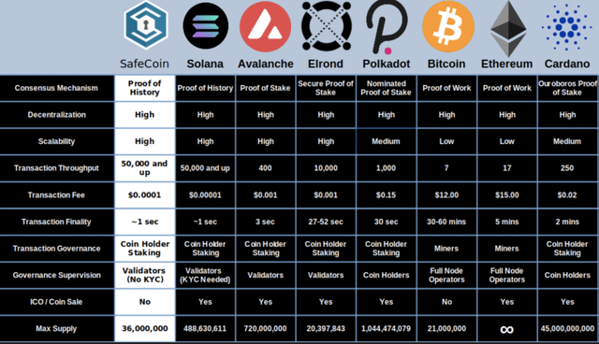

**Fig-3: Comparison of blockchains [25]**

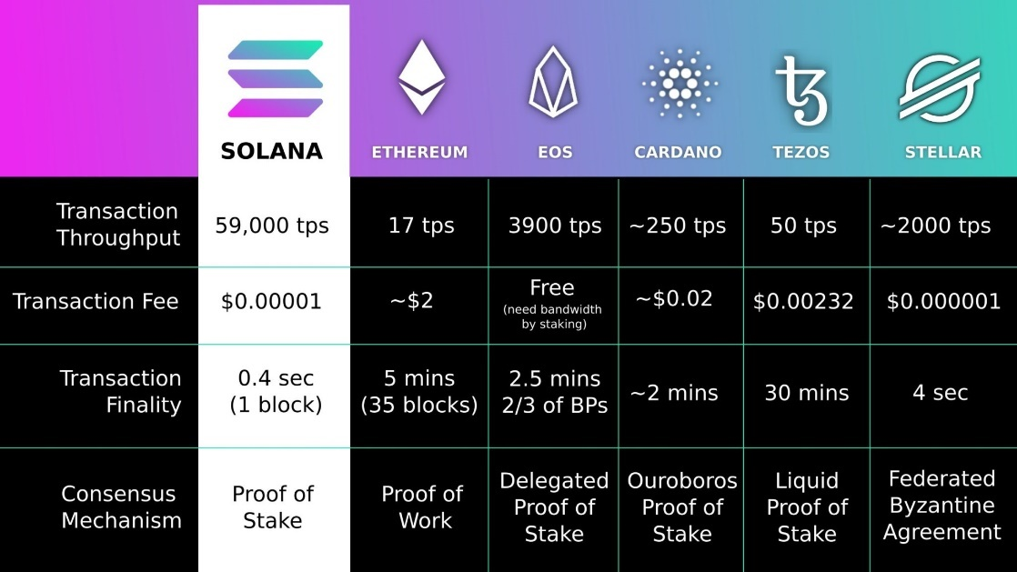

**Fig-4: Comparison of blockchains [26]**

**References:-**

1. <https://www.youtube.com/watch?v=gwiAdCliK14>
2. <https://www.investopedia.com/tech/most-important-cryptocurrencies-other-than-bitcoin/#toc-types-of-altcoins>
3. <https://www.investopedia.com/terms/g/gas-ethereum.asp>
4. <https://www.investopedia.com/terms/p/proof-stake-pos.asp>
5. <https://www.investopedia.com/terms/t/tezos.asp>
6. <https://www.investopedia.com/cardano-definition-4683961>
7. <https://www.coindesk.com/tech/2022/02/10/the-top-ethereum-killers-compared/#:~:text=Ethereum's%20top%20competitors,%2C%20Cardano%2C%20Tezos%20and%20Polkadot>.
8. <https://www.investopedia.com/news/4-blockchain-contenders-competition-ethereum/>
9. <https://money.usnews.com/investing/cryptocurrency/articles/blockchain-investments-that-compete-with-ethereum>
10. <https://cryptobullsclub.com/top-ethereum-alternatives/>
11. <https://polkadot.network/Polkadot-lightpaper.pdf>
12. <https://www.gemini.com/cryptopedia/dot-crypto-polkadot-blockchain#section-substrate-and-polkadot-application-development>
13. <https://polkadot.network/blog/the-parachain-advantage-exploring-polkadots-next-generation-model/#:~:text=Polkadot%20allows%20transactions%20to%20be,scalability%20over%20non%2Dsharded%20networks>
14. <https://www.blockchain101.org/cryptocurrency-course/tezos/lessons/tezos-architecture/>
15. <https://tezos.gitlab.io/active/consensus.html>
16. <https://www.blockchain-council.org/ethereum/what-is-polygon-matic-how-does-polygon-work/>
17. <https://www.investopedia.com/polygon-matic-definition-5217569>
18. <https://docs.cardano.org/introduction>
19. <https://coinmarketcap.com/alexandria/article/a-deep-dive-into-cardano>
20. <https://medium.com/cardanorss/consensus-on-cardano-vs-other-blockchains-ef5e7f05e495>
21. <https://developers.cardano.org/docs/stake-pool-course/introduction-to-cardano/>
22. <https://www.investopedia.com/uniswap-uni-definition-5217463>
23. <https://www.investopedia.com/non-fungible-tokens-nft-5115211>
24. <https://www.ionos.ca/digitalguide/online-marketing/online-sales/blockchain/>
25. <https://www.uptobrain.com/business/ethereum-is-still-the-king-among-developers-but-why-competitors-are-growing-rapidly/>
26. <https://seekingalpha.com/article/4469557-solana-is-a-highly-undervalued-blockchain>
27. <https://www.fool.ca/2021/12/23/3-ethereum-competitors-that-could-outperform-ether-in-2022/>
28. <https://www.howtogeek.com/782335/what-is-ethereum-2.0-and-will-it-solve-cryptos-problems/#:~:text=Network%20Congestion%3A%20In%20times%20of,run%20on%20the%20Ethereum%20network>.
29. <https://www.computer.org/publications/tech-news/trends/end-bitcoins-blockchain-dominance>
30. <https://www.investopedia.com/terms/b/blockchain.asp#toc-blockchain-vs-banks>
31. <https://www.mdpi.com/2073-8994/11/10/1198/htm>